HAAS 3-AXIS CNC

OPERATING INSTRUCTIONS

Jack Slocum

Sam Arnold

Barett Strecker

Robert Melchione

5/28/2014



**TABLE OF CONTENTS**

CONTROL PANEL OVERVIEW…………………………………………………. 3

MACHINE STARTUP INSTRUCTIONS…………………………………………. 5

PROGRAM PREPARATION………………………………………………………. 5

MASTERCAM PROGRAMMING…………………………………………………. 7

MACHINE OPERATION…………………………………………………………… 13

## 

## 

# **CONTROL PANEL OVERVIEW**

General organization:

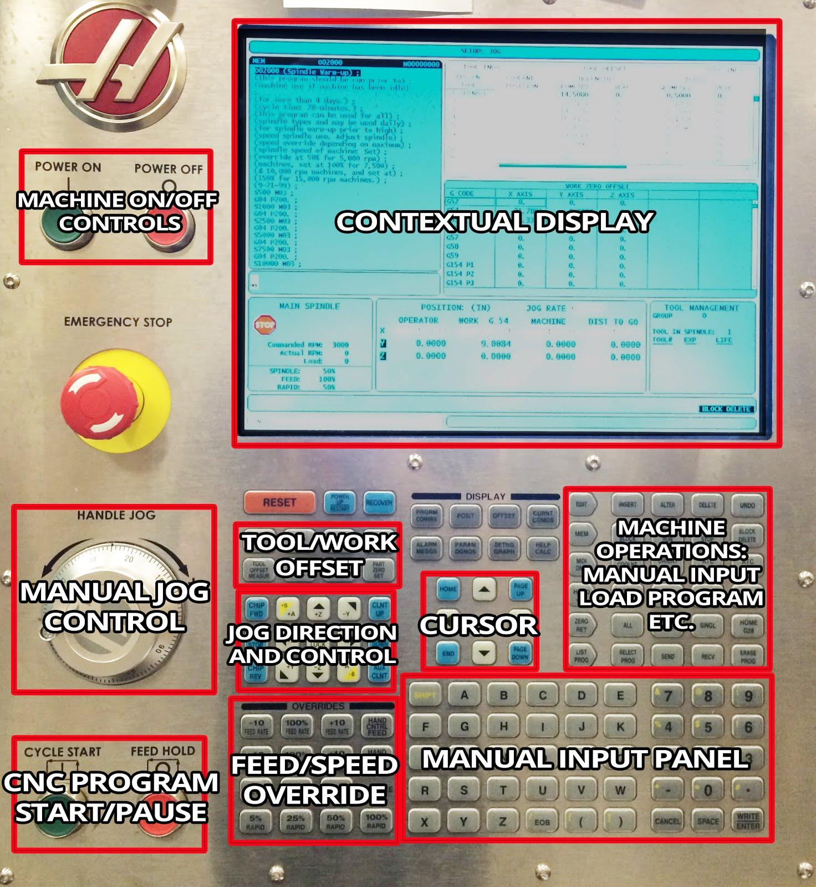

Detail view of common operations: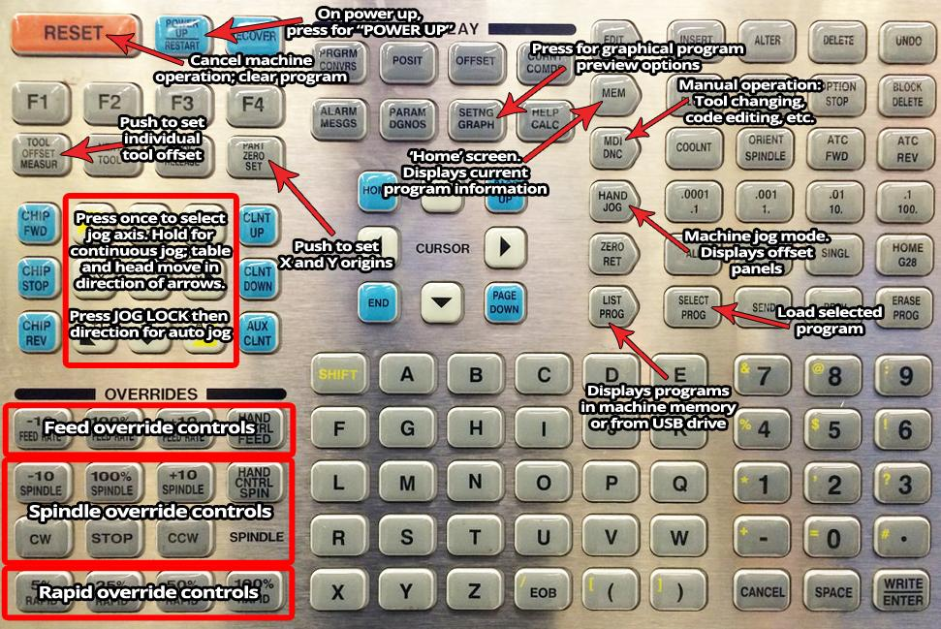

## 

## 

# **MACHINE STARTUP INSTRUCTIONS**

1. Start up machine following the prompts
   1. Push the **POWER ON** button
   2. Follow the prompts in the yellow blinking box on the left side:
      1. **EMERGENCY STOP** on and off
      2. Close door (make sure the vice handle has been removed or it will crash into the door)
      3. Push **RESET**
      4. Push **POWER UP**
         1. Wait until final beep
2. Run spindle warm up program program number **002000**
   1. Push **LIST PROGRAM**
   2. Push **ENTER** to open machine memory tab
   3. Scroll to the **002000** program, so it is highlighted
   4. Push **SELECT PROGRAM**, *not* **ENTER**
   5. Press **MEM** and look at the program in the memory panel to verify that program **002000** is loaded
   6. Use Spindle Override to decrease spindle to 50%. This is necessary based on the max. RPM of the machine, which is 5000 RPM.
   7. Cycle start
      1. This program takes 20 minutes, and will incrementally increase the spindle speed up to 5000 RPM
3. Turn the machine light on. The button is located on the side of the control box, indicated by a light symbol

# **PROGRAM PREPARATION**

1. Open your part in Solidworks
2. Create coordinate system that will allow you to zero X, Y, and Z coordinates once your stock is in the machine.
   1. Sketch a location you could measure on your stock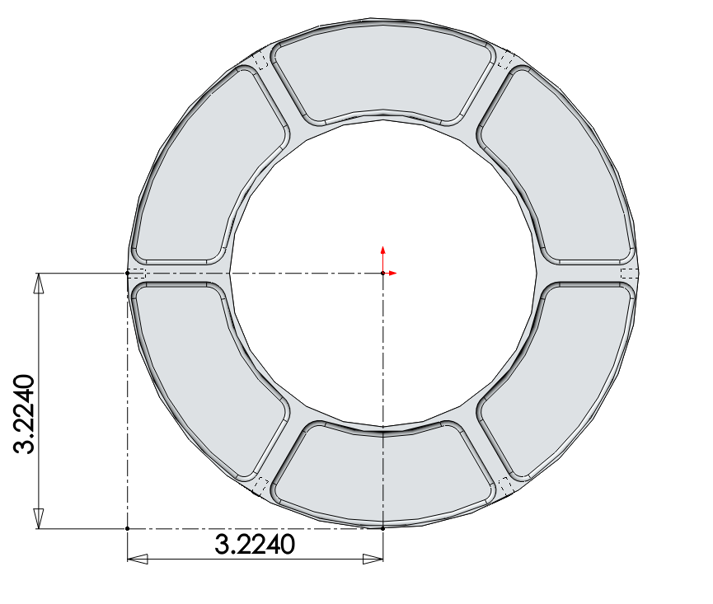
   2. Create coordinate system, where Z is out of the screen toward you, X is to your right, and Y is up
   3. 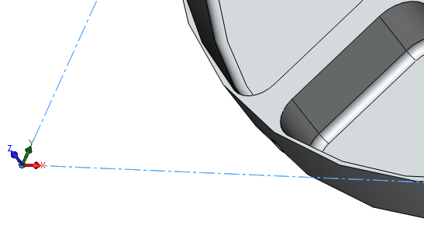
   4. 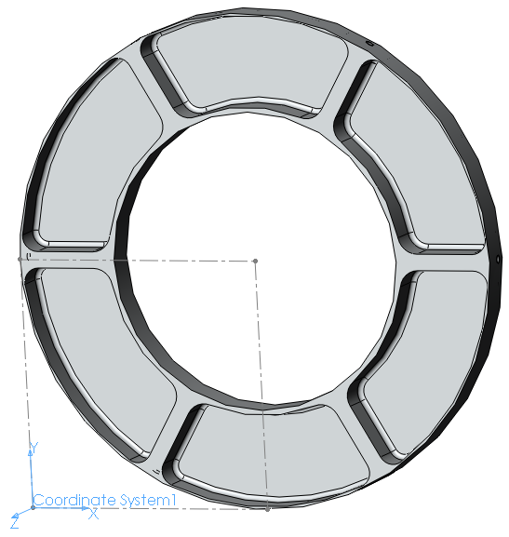
   5. Save as IGES file type, and before clicking OK, click **Options** from the dropdown at the bottom of the window, set your output coordinate system to the one you just created
   6. 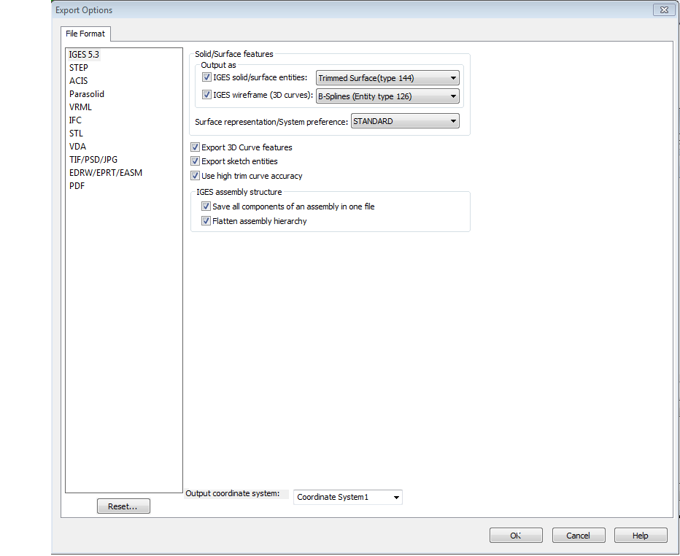

# **MASTERCAM PROGRAMMING**

1. Open MasterCAM x7
2. Open your IGES part
   1. Your part should pop up facing you the way you intend to machine it
   2. 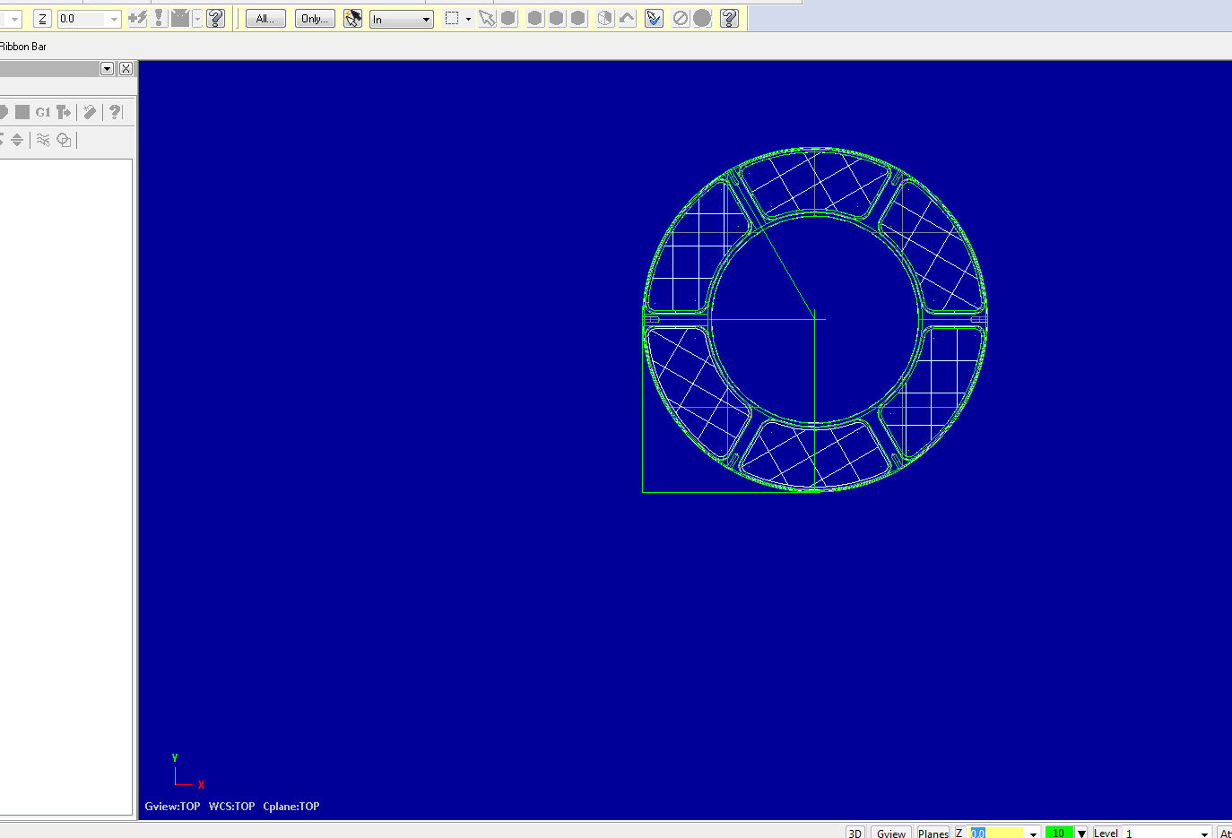
   3. Select shaded, outlined icon to display part surfaces and outlines
   4. 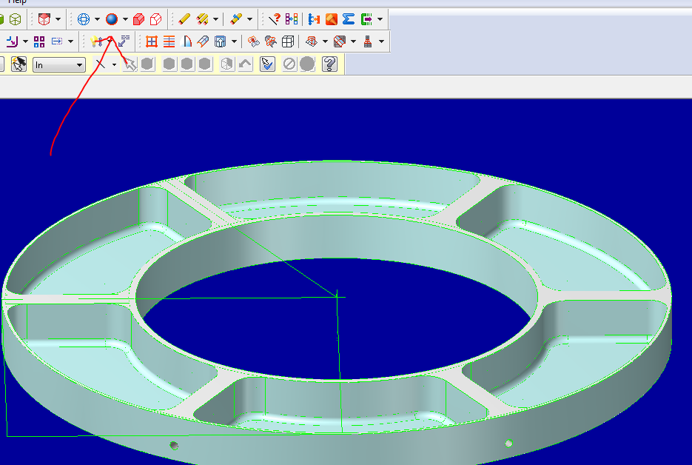
3. Click **Machine Type > Mill > Manage List\*** (*only necessary if the Haas 3-axis is not already listed)

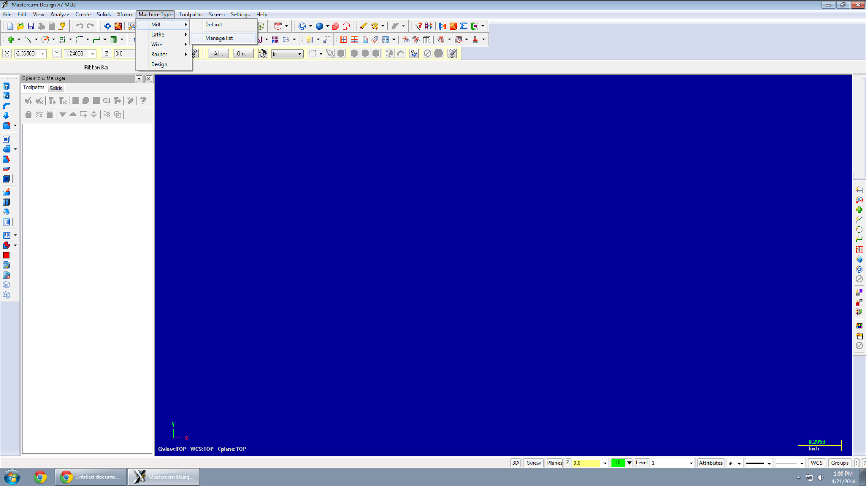

* 1. Add **Prototrak** and **Haas 3 axis mill**

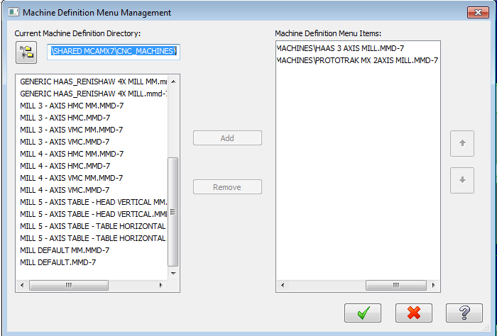,

* 1. Go back to the dropdown, **Machine Type > Mill > Haas 3 Axis**

1. At the top of the window, click **Toolpaths > Contour** (a contour path follows the path of a line)
   1. Define the NC file name as the date, followed by a 2 digit number like 01

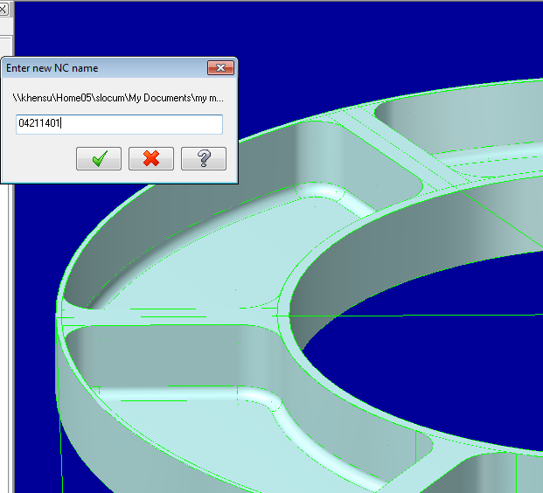

* 1. Select the contour lines you want to cut on. These lines can often be difficult to see. The red arrow is where your tool will finish its path, the green arrow is where it will begin. In general, you want to green and red arrows to end up on top of each other for a closed path. Click the **Green Checkmark.**
  2. In the subsequent toolpaths window, click the **Tool** item in the left column, then click **Select library tool,** and find/select the tool you plan to use. You might have to uncheck “filter active.”

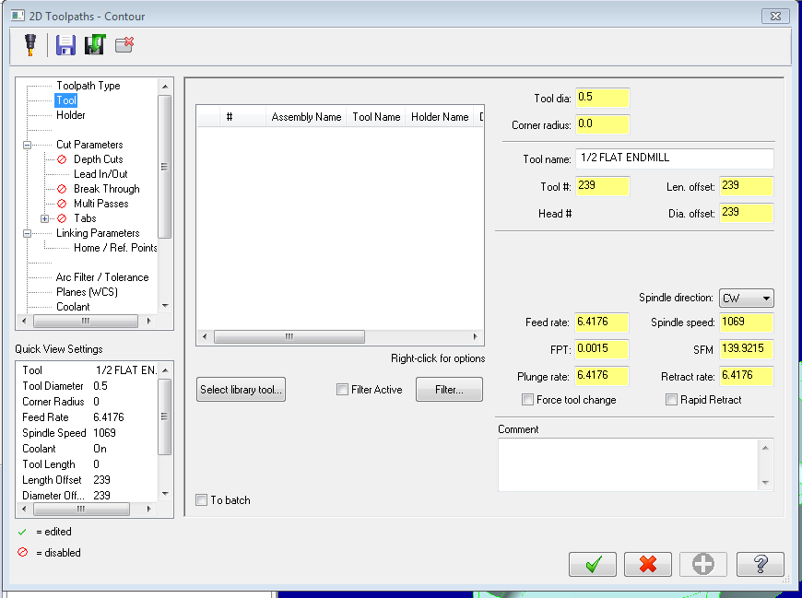

* 1. On the Haas, it is critical that the **Tool #, Head #, Len. offset** and **Dia. offset** are the same number. This number should match the tool’s position number indicated on the Haas tool carousel. This is how the machine knows what the tool geometry is. General feeds and speeds: aluminum, .5” diameter tool > 2200 rpm, 6 feed, 3 plunge. Smaller cutters generally need faster RPM and slower feed. Harder materials generally need slower RPM and slower feed.
  2. Select **Linking Parameters** from the options tree on the left. The depth is the final depth of the cutter. Make sure each parameter is **Absolute**.

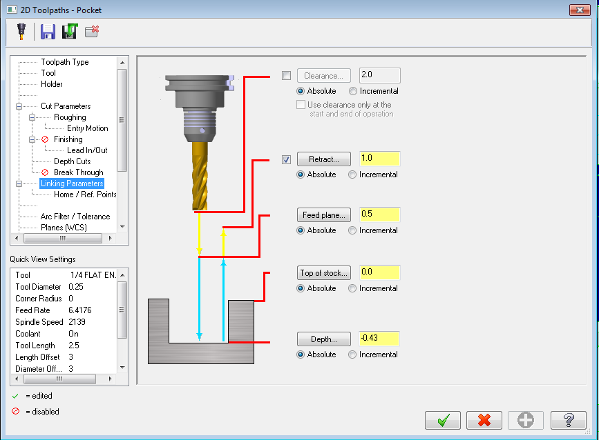

* 1. Select **Depth Cuts** from the options tree. This defines the depth of cut for each pass.
  2. **Max rough step** is depth per pass. The computer figures out the number of passes necessary based on your maximum rough step. For aluminum with 0.5” cutter, 0.25” is a safe depth per pass.
  3. Click the **Green Checkmark**

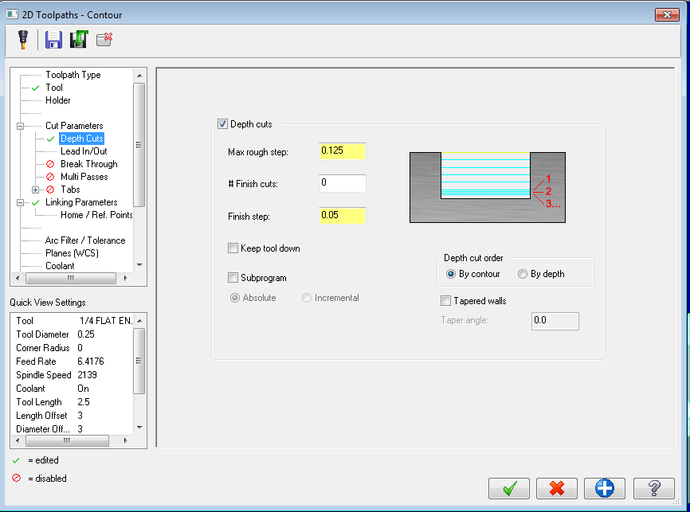

1. Click dropdown, **Toolpaths > Pocket**
   1. For making a pocket with a bottom fillet, you must select the inner contour located on the floor of the pocket for the initial pocketing pass. Click the contours where you want the pocket to be.
   2. Select the chain remembering to click just ahead of the red arrow each time until you get back to the green arrow
   3. When finished, click the **Green Checkmark**
   4. Select **Cut Parameters** from the options tree. Constant overlap and helix entry motion are common for pockets.
   5. Set **Depth Cuts** and **Linking Parameters** the same as in the contour path.
   6. Click the **Green Checkmark**
   7. Click **Geometry** in the toolpath tree, then **Right Click > Add Chain**
      1. If the toolpaths are on the wrong side, you can **Right Click > Change Side**, or **Right Click > Reverse Chain**.
2. Create fillet contour path
   1. Click on the line at the top of the fillet against the wall. This is how you will leave the fillet when using a ball end or radiused end mill
3. Select all the programs on the left side (ctrl click) so they are all checkmarked, or simply click on the top **Toolpath Group**. Make sure all paths have a green checkmark next to them.

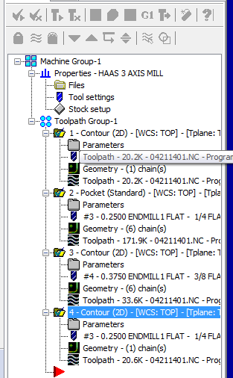

* 1. Click the **G1 icon** and then click the **Green Checkmark**
  2. Save the output file to a thumb drive by dragging files from network location into a “Programs” folder on your thumb drive.
  3. Put your thumb drive in the USB port on the side of the machine

# **MACHINE OPERATION**

1. Put the tools you want to use in the machine
   1. Put each tool in the appropriate collet
   2. Rotate the carousel until it is at the tool number you want to put the tool in (the same one you set as the **Tool #, Len. Offset, etc.**)
      1. To rotate the carousel, push the **MDI** button for manual input, then push the **ATC FWD** or **ATC REV** to move to the next or previous tool.
      2. To skip to a specific tool, enter the tool code+number (ex: “T4”) in the input field, then push **ATC FWD** or **ATC REV**.
   3. Push and hold the round, black button on the spindle column and align the two teeth on the spindle with the slots on the collet
   4. Let go of the button when it is aligned, and the collet should be sucked up into the spindle.
2. Load the stock into the machine and square up the stock. For manual machining operation:
   1. Click **Hand Jog**, thenset your jog increment to .01”, then select an axial direction (ex: **X-**). You can either hold the axial direction button to jog, or you can use the hand wheel to jog. Note that each increment on the hand wheel is equal to the selected jog increment. This is how you will be able to manually direct the machine. You must be very careful to not crash the machine. When jogging the machine at a high rate, the machine coasts for a bit after you stop, so it is very easy, especially in the Z direction, to crash into things. **Always check your selected axial direction and jog increment before jogging on the machine.**
   2. To start the spindle, push the **MDI** button and type your desired RPM into the input field (ex: “1500”) and then push the **CW** button.
   3. To start the coolant, push the **COOLNT** button. If the coolant does not start, make sure the valve on the nozzles is open. You can control the flow rate using this valve.
   4. Make sure to take off the vice handle before any machine operations.
   5. You can push the **JOG LOCK** button and then push the axial direction you want to jog in. Push **JOG LOCK** again to stop the machine. Note that there are two ways to control the jog feed rate: the jog increment and the feed override. Make sure you have a reasonable jog feed rate before cutting by jogging away from your workpiece.
3. Define your **Tool Offsets** and **Part Zeros** for the stock. These should match the location of your coordinate system origin that you created in SolidWorks.
   1. Define tool heights, which essentially defines the Z direction origin for each tool.

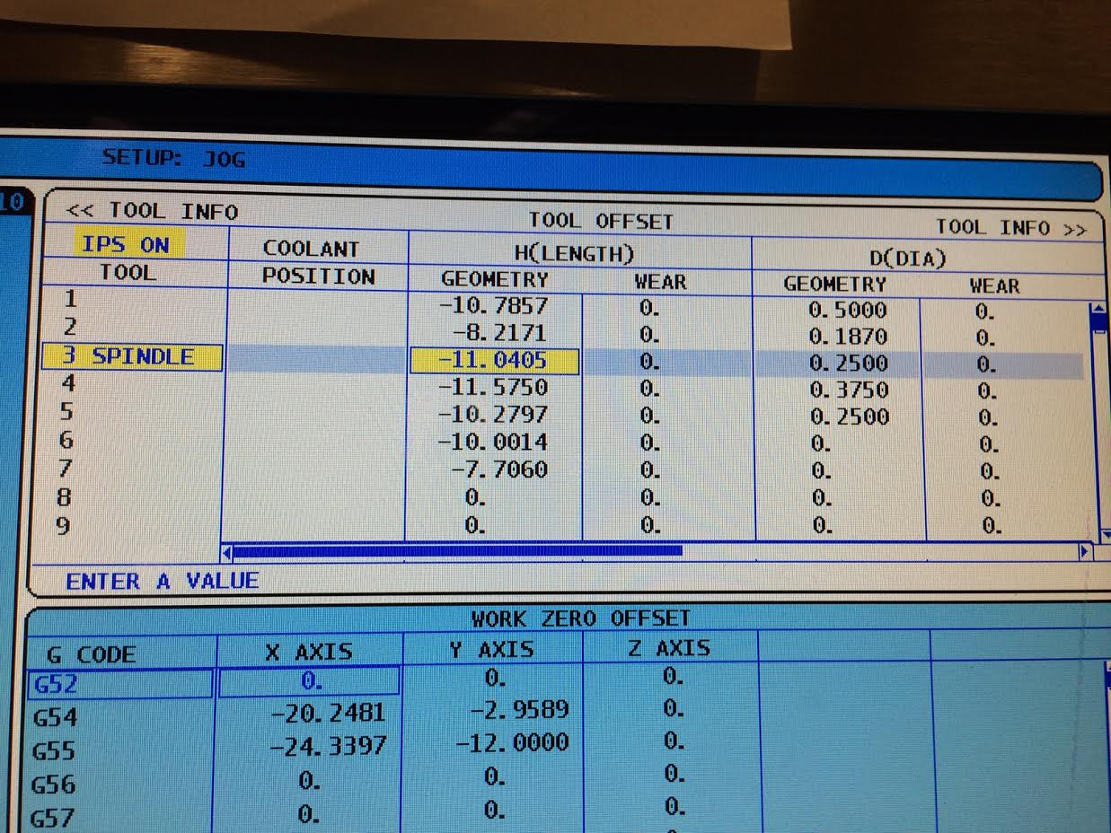

* + 1. Jog each tool to down close to the surface of the part with the spindle off
    2. Take a piece of paper and put it between the tip of the cutter and the surface of the part
    3. Move the paper back and forth under the tool and move the head down very slowly (.001” jog increment) using the hand wheel until the paper is pinched between the tool and surface (the paper stops moving).
    4. Push the **OFFSET** button to get to the tool offset panel (the active panel background should be white)
    5. Use the D-pad to move the cursor to highlight the appropriate **H(LENGTH)** **GEOMETRY** cell for the tool you are trying to zero (ex: Tool 3 in the photo above)
    6. Push **TOOL OFFSET MEASURE**. Because of the paper method used, you will still be between 0.001” to 0.003” above the part. This is generally within tolerance. For higher precision, use a different method.
    7. Switch tools and repeat for all tools in your program
  1. Now we need to zero the work, which defines the X and Y direction origins.

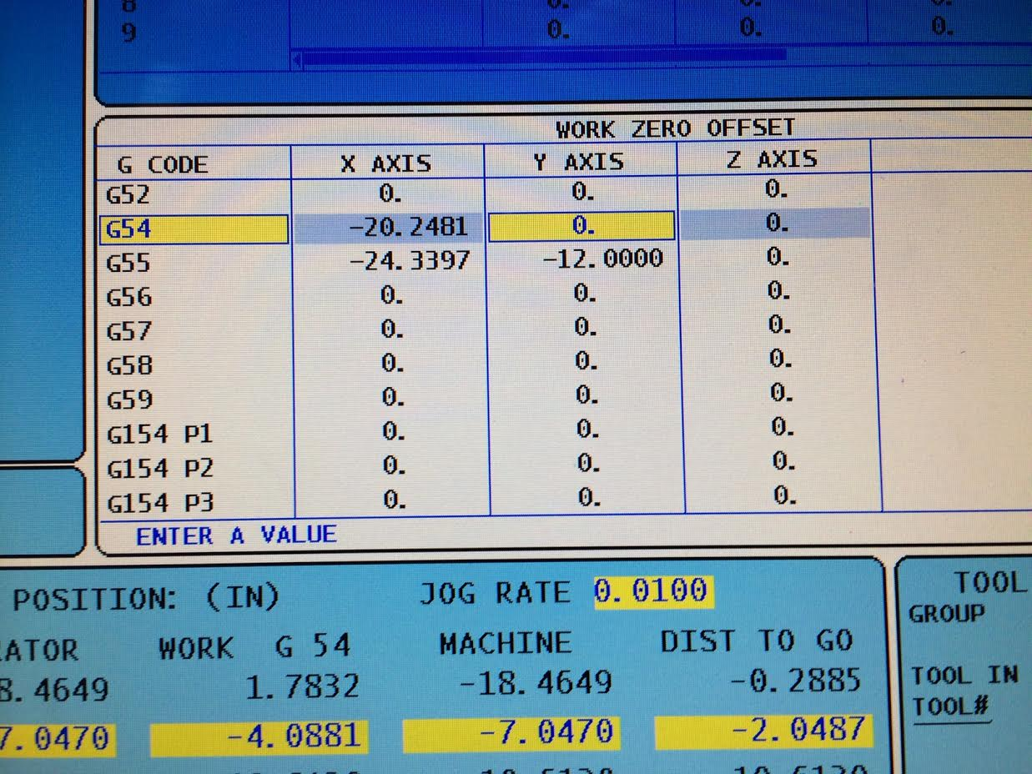

* + 1. Jog the machine to the X and Y origin location using an edge finder tool or by some other method, depending on how you plan to machine your part.
    2. Push the **OFFSET** button to switch the active offset panel to **WORK ZERO OFFSET**
    3. Make sure you are working in the **G54** row
    4. Move the cursor over to the **X AXIS** column and push the **PART ZERO SET** button to zero X, then cursor over to the **Y AXIS** column to zero Y.
    5. Do not change the **Z AXIS** part zero. This was set by your tool length offsets. You can set Z to a large positive number to make your program run above the part before cutting to check for errors. Be sure to make it larger than your deepest cut. To set this value, enter a value with decimal after the number (ex. “4.”) the hit **F1**, then hit **Y** on the keypad to confirm.

1. Import your program to the machine
   1. Push **LIST PROGRAM**
   2. Cursor over to the **USB DEVICE** tab, then push **ENTER**
   3. Scroll to the program program file to highlight it
   4. Push **SELECT PROGRAM**, *not* **ENTER**
2. Preview the program graphically by pushing the **SETNG GRAPH** button twice, then push the green **CYCLE START** button. This will verify that there are no errors in the program. Keep an eye on the tool numbers to make sure the program is running as planned.
3. Run the program above your part as described in the part zero section above
   1. Push **MEM**
   2. Make sure to override your feed and rapid rate to very low speeds so you have time to observe and react in case the machine crashes. You can take the spindle to 0% if you want.
   3. For this demo, we are using a 0.25” cutter at 1.5 plunge rate, 9.5 feed and 3000 RPM
   4. Push **CYCLE START** and pay close attention to the toolpaths to make sure everything runs smoothly.
4. Run the final program
   1. Push **OFFSET** to get the the work offset panel, scroll to the **Z AXIS** column in the **G54** row, and enter “0.” in the input field, then push **F1** to submit, **Y** to confirm. This resets your Z zero to the actual origin.
   2. Push **CYCLE START**
   3. Make sure the coolant comes on. If not, push the **COOLNT** button.
   4. To pause the program, push **FEED HOLD**. To resume, push **CYCLE START**.
   5. To stop spindle during feed hold, push **STOP** in the spindle override